

DB생명 디지털판매Site구축 사업

소스코드 취약점 점검 보고서

Ver 1.0

개 정 이 력

버전 | 변경일 | 변경내용 | 작성자 | 승인자
1.0 | 2023.11.13 | 산출물 최초작성 | 김두포 | 윤진한

목 차

1. 개요 １
1.1 목적 １
1.1.1 업무분장 １
1.1.2 취약점 분석 대상 １
1.1.1 취약점 분석 수행 일정 １
2. 점검 항목 ２
2.1 Bug ２
2.2 Vulnerability ５
3. 수행 방법 ７
4. 재 진단 및 결과 ８
4.1 사용자 ８
4.1.1 Unresolved : 0개 ８
4.1.2 Fixed : 0개 ９
4.1.3 False Positive : 86개 ９
4.1.4 Won't fix : 0개 ９
4.2 관리자 １０
4.2.1 Unresolved : 0개 １０
4.2.1 Fixed : 0개 １０
4.2.2 False Positive : 269개 １１
4.2.3 Won't fix : 0개 １１
4.3 공통 １２
4.3.1 Unresolved : 0개 １２
4.3.1 Fixed : 58개 １３
4.3.2 False Positive : 42개 １３
4.3.3 Won't fix : 270개 １４

개요

목적
본 계획서는 웹어플리케이션을 분석하여 취약점을 진단하고, 악의적 목적으로 접근하는 웹 서비스 이용자의 불법적인 권한 획득 및 도욕과 같은 침해 사고를 미연에 방지하기 위한 목적으로 수행한다.
또한 시스템 구간에 존재하는 보안상 취약점을 진단 분석하고 이에 대한 적절한 보안대책을 제시하여 정보 자산의 보안수준을 강화하고자 한다.

업무분장
역할 | 책임 | 담당자
취약점 분석 | 각 보안 취약점 분석의 스케줄 및 진행을 담당 | AA
취약점 수정 | 각 보안 취약점 분석결과에 대한 처리를 담당 | 각 업무 PL 및 개발자

취약점 분석 대상
대상 | 업무 | 비고
dbcm-app | 사용자
dbcm-admin | 관리자
dbcm-co | 공통

취약점 분석 수행 일정
일정 | 일정 | 담당자 | 비고
소스 취약점 검사 계획 수립 | 2023.10.02 | AA
검사 실시 | 2023.10.09 ~ 10.31 | AA
검사 결과 조치 및 보완 | 2023.10.16 ~ 10.31 | 각 업무 PL 및 개발자

점검 항목
DB Inc 제공하는 Quality Profile을 기준으로 검사.

Bug
- Bug내 Blocker, Critical, Major에 해당하는 사항만 체크.
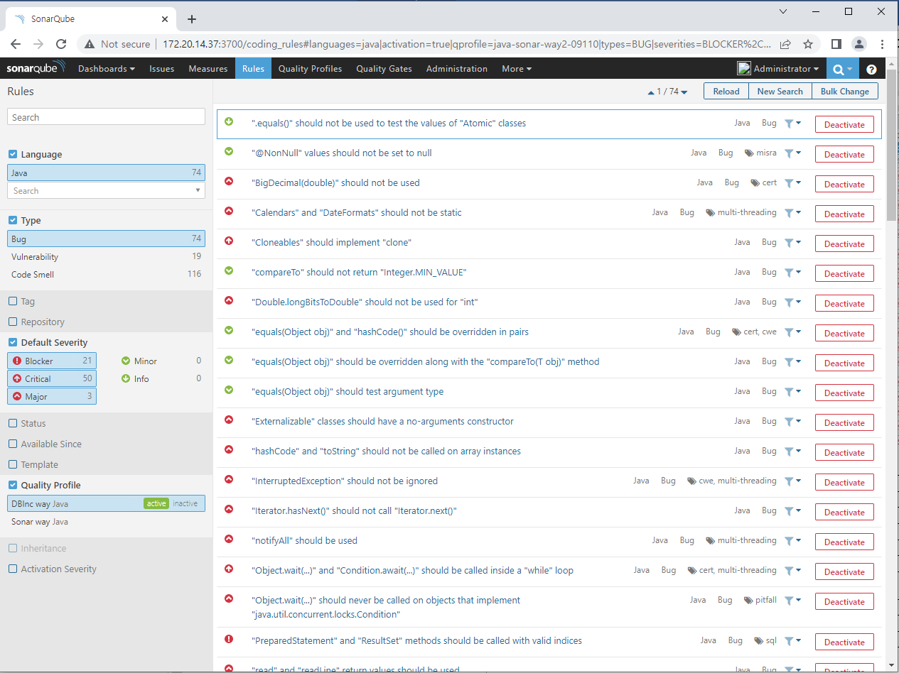

- 해당 취약점 74개

".equals()" should not be used to test the values of "Atomic" classes
"@NonNull" values should not be set to null
"BigDecimal(double)" should not be used
"Calendars" and "DateFormats" should not be static
"Cloneables" should implement "clone"
"compareTo" should not return "Integer.MIN_VALUE"
"Double.longBitsToDouble" should not be used for "int"
"equals(Object obj)" and "hashCode()" should be overridden in pairs
"equals(Object obj)" should be overridden along with the "compareTo(T obj)" method
"equals(Object obj)" should test argument type
"Externalizable" classes should have a no-arguments constructor
"hashCode" and "toString" should not be called on array instances
"InterruptedException" should not be ignored
"Iterator.hasNext()" should not call "Iterator.next()"
"notifyAll" should be used
"Object.wait(...)" and "Condition.await(...)" should be called inside a "while" loop
"Object.wait(...)" should never be called on objects that implement "java.util.concurrent.locks.Condition"
"PreparedStatement" and "ResultSet" methods should be called with valid indices
"read" and "readLine" return values should be used
"return" statements should not occur in "finally" blocks
"runFinalizersOnExit" should not be called
"ScheduledThreadPoolExecutor" should not have 0 core threads
"Serializable" inner classes of non-serializable classes should be "static"
"SingleConnectionFactory" instances should be set to "reconnectOnException"
"toString()" and "clone()" methods should not return null
"wait(...)", "notify()" and "notifyAll()" methods should only be called when a lock is obviously held on an object
A "for" loop update clause should move the counter in the right direction
Assertions should be complete
Assignments should not be made from within sub-expressions
Blocks synchronized on fields should not contain assignments of new objects to those fields
Classes should not be compared by name
Collections should not be passed as arguments to their own methods
Conditions should not unconditionally evaluate to "TRUE" or to "FALSE"
Custom serialization method signatures should meet requirements
Default EJB interceptors should be declared in "ejb-jar.xml"
Dissimilar primitive wrappers should not be used with the ternary operator without explicit casting
Fields in a "Serializable" class should either be transient or serializable
Identical expressions should not be used on both sides of a binary operator
IllegalMonitorStateException should not be caught
Inappropriate "Collection" calls should not be made
Inappropriate regular expressions should not be used
Instance methods should not write to "static" fields
Ints and longs should not be shifted by more than their number of bits-1
Invalid "Date" values should not be used
JUnit assertions should not be used in "run" methods
JUnit framework methods should be declared properly
JUnit test cases should call super methods
Locks should be released
Loop conditions should be true at least once
Loops should not be infinite
Math operands should be cast before assignment
Methods "wait(...)", "notify()" and "notifyAll()" should never be called on Thread instances
Methods should not be named "hashcode" or "equal"
Multiline blocks should be enclosed in curly braces
Neither "Math.abs" nor negation should be used on numbers that could be "MIN_VALUE"
Non-public methods should not be "@Transactional"
Non-serializable classes should not be written
Non-serializable objects should not be stored in "HttpSessions"
Null pointers should not be dereferenced
Printf-style format strings should not lead to unexpected behavior at runtime
Raw byte values should not be used in bitwise operations in combination with shifts
Reflection should not be used to check non-runtime annotations
Related "if/else if" statements should not have the same condition
Return values should not be ignored when function calls don't have any side effects
Servlets should not have mutable instance fields
Short-circuit logic should be used in boolean contexts
Silly equality checks should not be made
super.finalize() should be called at the end of Object.finalize() implementations
Synchronization should not be based on Strings or boxed primitives
The non-serializable super class of a "Serializable" class should have a no-argument constructor
The value returned from a stream read should be checked
Thread.run() and Runnable.run() should not be called directly
Values should not be uselessly incremented
Variables should not be self-assigned

Vulnerability
- 취약점 내 Blocker, Critical, Major에 해당하는 사항만 체크.
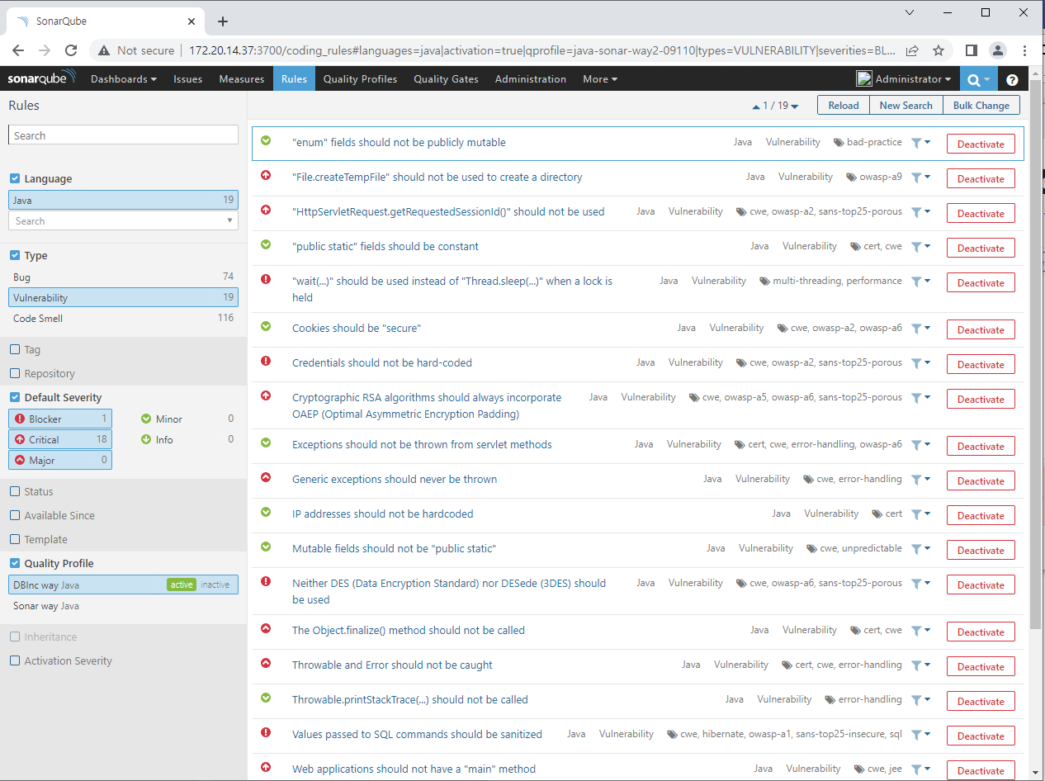

- 해당 취약점 19개
"enum" fields should not be publicly mutable
"HttpServletRequest.getRequestedSessionId()" should not be used
"public static" fields should be constant
"wait(...)" should be used instead of "Thread.sleep(...)" when a lock is held
Cookies should be "secure"
Credentials should not be hard-coded
Cryptographic RSA algorithms should always incorporate OAEP (Optimal Asymmetric Encryption Padding)
Exceptions should not be thrown from servlet methods
Generic exceptions should never be thrown
IP addresses should not be hardcoded
Mutable fields should not be "public static"
Neither DES (Data Encryption Standard) nor DESede (3DES) should be used
The Object.finalize() method should not be called
Throwable and Error should not be caught
Throwable.printStackTrace(...) should not be called
Values passed to SQL commands should be sanitized
Web applications should not have a "main" method
Web applications should use validation filters

수행 방법
 | 작업구분 | 수행방법 | 비고
1 | 웹취약점 점검 | SonarQube를 이용하여 소스 취약점 스캔 실행
2 | 결과 분석 | 취약점 점검결과를 각 업무 PL에게 전달
3 | 결과에 따른 코드 수정 | 각 업무 PL은 각 담당개발자에게 수정 요청
4 | 웹취약점 재 점검 | 재 점검

재 진단 및 결과

사용자

Unresolved : 0개
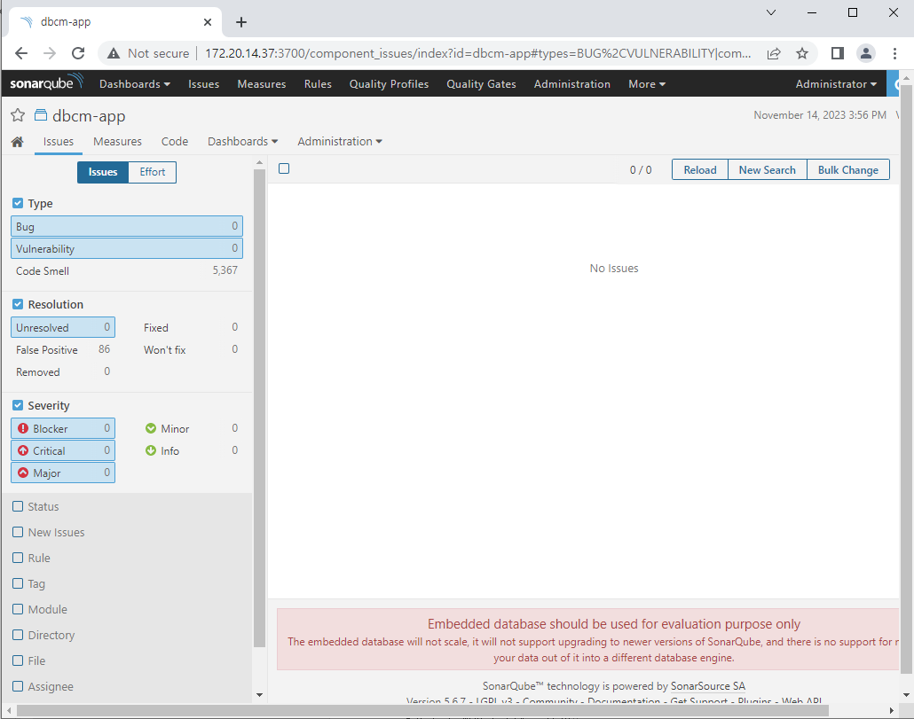
- Bug 및 취약점, Blocker, Critical, Major에 대해 해결안된 사항 없음.

Fixed : 0개
- Bug나 취약점 있던 소스 모두 수정하고 재분석

False Positive : 86개
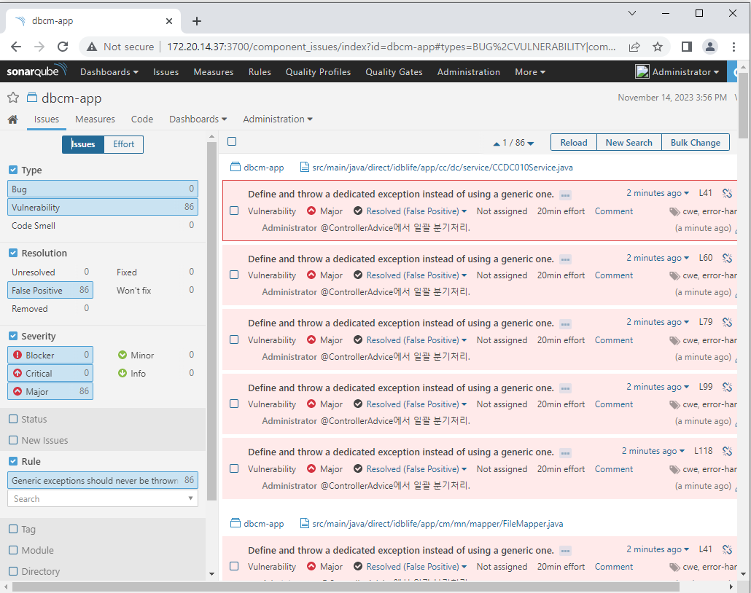
- 전부 Concrete Exception을 throw하라는 것으로 실제 @ControllerAdvice에서 일괄 상세 분기 처리 하고 있음.

Won't fix : 0개

관리자

Unresolved : 0개
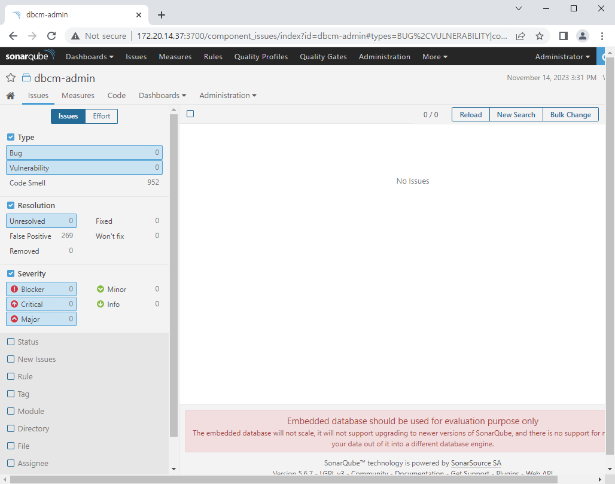
- Bug 및 취약점, Blocker, Critical, Major에 대해 해결안된 사항 없음.

Fixed : 0개

False Positive : 269개
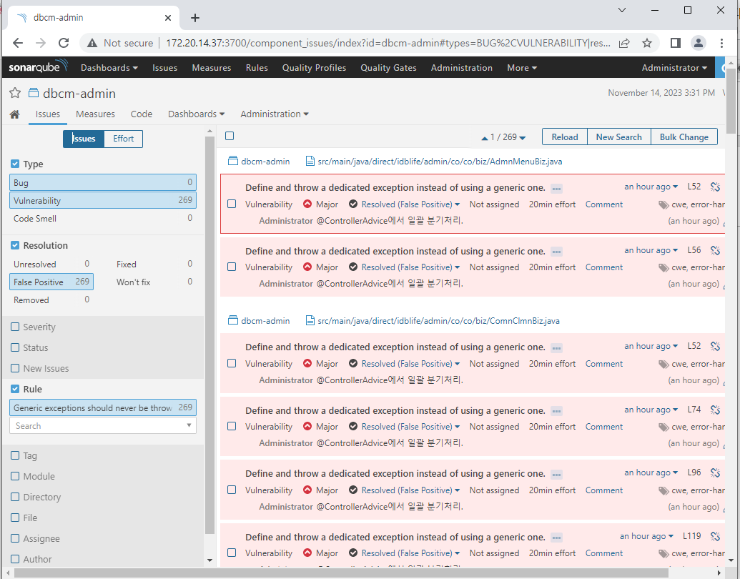
- 전부 Concrete Exception을 throw하라는 것으로 실제 @ControllerAdvice에서 일괄 상세 분기 처리 하고 있음.

Won't fix : 0개

공통

Unresolved : 0개
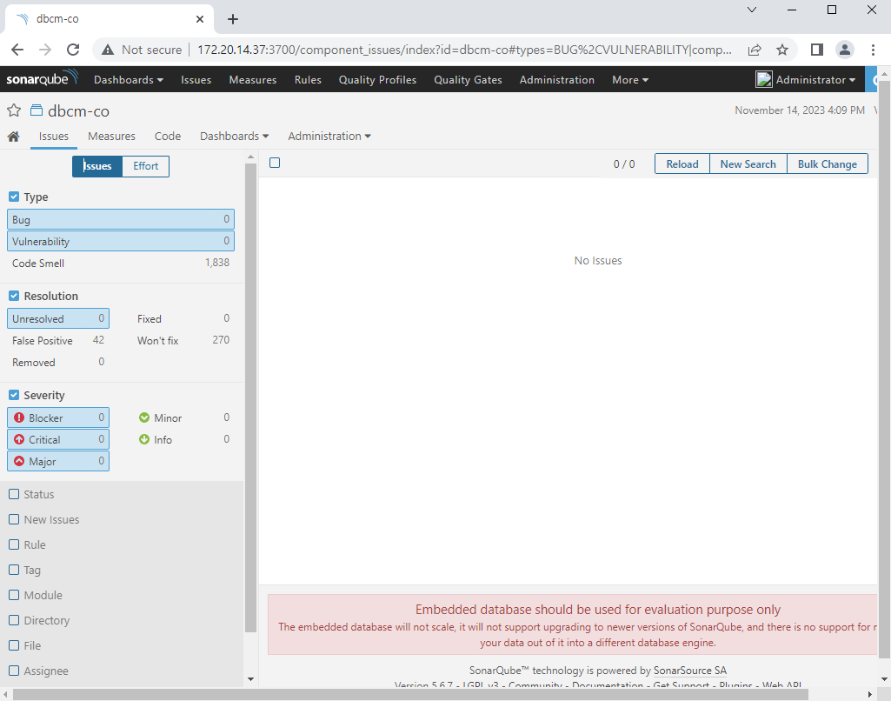
- Bug 및 취약점, Blocker, Critical, Major에 대해 해결안된 사항 없음.

Fixed : 58개

False Positive : 42개
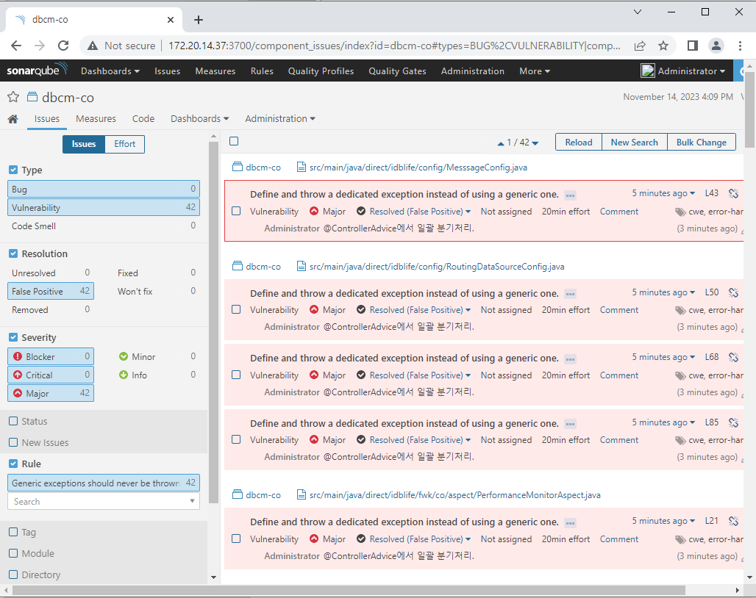
- 전부 Concrete Exception을 throw하라는 것으로 실제 @ControllerAdvice에서 일괄 상세 분기 처리 하고 있음.

Won't fix : 270개
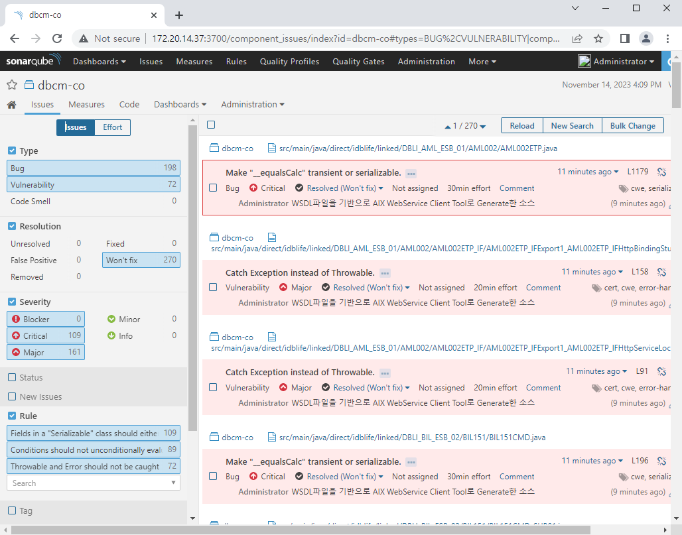
- WSDL파일을 기반으로 AIX WebService Client Tool에서 Generate한 소스로 WSDL 변경시 DBInc Way에서 제시한 규칙대로 코딩을 유지할수 없음.

변경 내용: 변경이 발생되는 위치와 변경 내용을 자세히 기록(장.절과 변경 내용을 기술한다.)

