1. Jenkins

1.1. 접속정보
http://172.16.3.102
root / cgbest2022 (관리자)
admin / 고도화2021@ (일반개발자)
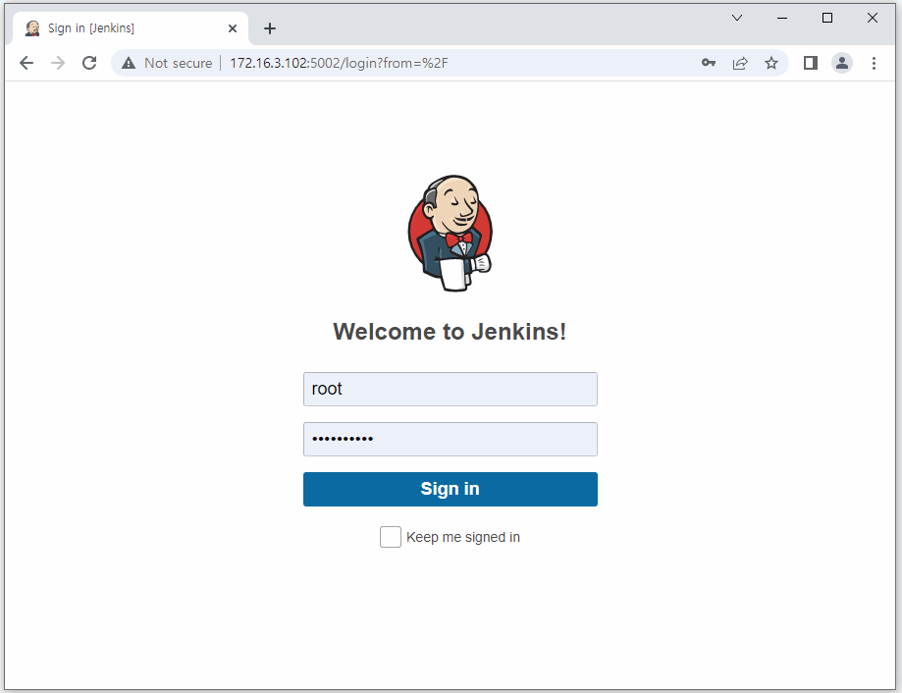

1.2. Job 분류
ㅁ SK 내부망/ 외부망
ㅁ CG 개발 내부망/ 외부망
ㅁ CG 테스트 내부망/ 외부망
ㅁ CG 운영 내부망/ 외부망
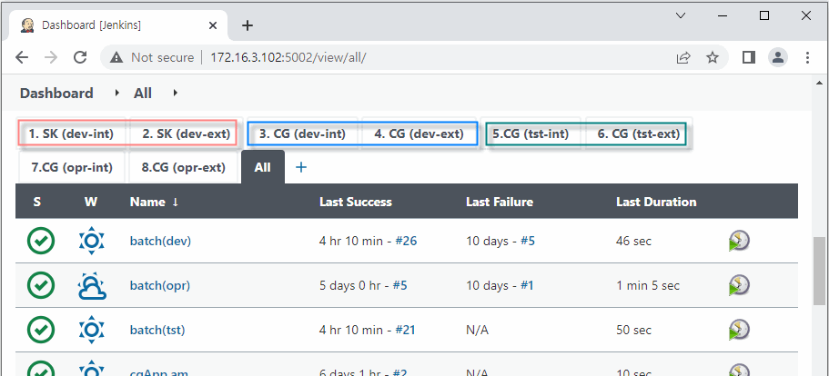

2. 배포순서
- Dependencies를 먼저 설정하고 즉, (WEB-INF/lib에 들어갈 .jar 라이브러리들 Download 받는것.)
- 해당 Library들을 가지고, cgApp (기간계 Application) 의 Framework가 되는 cgApp.fw.jar를 Build해서 Nexus에 등록.
- 각 업무단 Module들을 각 .jar로 패키징하여 Nexus에 등록.
- 최종, cgApp.core를 Build하면 cgApp.core에 있는 각종 .js, css, ui, websquare 등등 cgApp.core MainApplication을 중심으로 cgApp.fw 및 각 업무 .jar 들을 Nexus로 부터 불러와 cgApp.core-0.0.1-SNAPSHOT 디렉토리를 만든다.
(여기서 정적파일과, Application 파일들을 분리하는 작업은 ShellScript로 하고, 최종 Server Shutdown 및 Startup을 한다.)

2.1. 내부망

ㅁ 기간계
- cgApp.parent.deploy-pom
- cgApp.fw

- cgApp.am
- cgApp.au
- cgApp.bs
- cgApp.ce
- cgApp.ch
- cgApp.cm
- cgApp.cu
- cgApp.ga
- cgApp.ms
- cgApp.pi
- cgApp.sa
- cgApp.ss

- cgApp.core-int
- cgApp.core-ext

ㅁ 배치
- cgBatch

ㅁ 레포트
- cgOz-int

2.2. 외부망

ㅁ 채널계
- cgExt.parent.deploy-pom
- cgExt.fw

- cgCyber
- cgContract
- cgEdoc
- cgInvg
- cgMobile
- cgPoint
- cgPrm

ㅁ 레포트
- cgOz-ext

3. 배포 분류

3.1. 빌드 ~ 서버재구동
- 각 프로젝트 Build하고, 각 서버 /cgapp/ci/tmp에 업로드, /cgapp/ci/deploy-cyber.sh ~ deploy-prm.sh (총 7개)

- 1. SK (dev-int)
- 2. SK (dev-ext)
- 3. CG (dev-int)
- 4. CG (dev-ext)
- 5. CG (tst-int)
- 6. CG (tst-ext)

3.2. 빌드만
- 7. CG (opr-int)
- 8. CG (opr-ext)

- /mnt/src/core-int(opr).web.tar # 운영 내부 WEB 1, 2번
core-int(opr).app.tar # 운영 내부 WAS 1번
core-int(opr).app2.tar # 운영 내부 WAS 2번
core-ext(opr).app.tar # 운영 외부 WAS 1번
core-ext(opr).app2.tar # 운영 외부 WAS 2번

cgBatch.tar # 운영 내부 WAS 1번
cgBatch2.tar # 운영 내부 WAS 2번

cgCyber.web.tar # 운영 외부 WAS 1, 2번
cgCyber.app.tar # 운영 외부 WAS 1번
cgCyber.app2.tar # 운영 외부 WAS 2번

cgContract.web.tar # 운영 외부 WAS 1, 2번
cgContract.app.tar # 운영 외부 WAS 1번
cgContract.app2.tar # 운영 외부 WAS 2번

cgEdoc.web.tar # 운영 외부 WAS 1, 2번
cgEdoc.app.tar # 운영 외부 WAS 1번
cgEdoc.app2.tar # 운영 외부 WAS 2번

cgInvg.web.tar # 운영 외부 WAS 1, 2번
cgInvg.app.tar # 운영 외부 WAS 1번
cgInvg.app2.tar # 운영 외부 WAS 2번

cgMobile.web.tar # 운영 외부 WAS 1, 2번
cgMobile.app.tar # 운영 외부 WAS 1번
cgMobile.app2.tar # 운영 외부 WAS 2번

cgPoint.web.tar # 운영 외부 WAS 1, 2번
cgPoint.app.tar # 운영 외부 WAS 1번
cgPoint.app2.tar # 운영 외부 WAS 2번

cgPrm.web.tar # 운영 외부 WAS 1, 2번
cgPrm.app.tar # 운영 외부 WAS 1번
cgPrm.app2.tar # 운영 외부 WAS 2번

oz-int(opr).tar # 운영 내부 WAS 1, 2번
oz-ext(opr).tar # 운영 외부 WAS 1, 2번

4. 운영배포

4.1. 내부망

ㅁ 기간계
ㅇ 실 대상 디렉토리
- 내부망 WEB 1, 2 /cgapp/apache/htdocs/core
- 내부망 WAS 1, 2 /cgapp/src/cgApp.int, /cgapp/src/cgApp.ext
ㅇ 배포스크립트 실행 및 서버 재구동
- 내부망 WEB 1, 2
배포
/cgappfiles/tmp/core-int(opr).web.tar에 파일을 먼저 위치 시켜놓고,
/cgappfiles/tmp/deploy-int-web.sh 실행
- 내부망 WAS 1, 2
1. 배포
/cgeonfiles/src/core-int(opr).app.tar, core-ext(opr).app.tar에 파일 먼저 위치시켜놓고,
/cgappfiles/tmp/deploy-app1.sh, deploy-app2.sh 실행
2. 서버재구동
/cgapp/weblogic/user_projects/domains/cgcoreDomain/stopapp.int11.sh
/cgapp/weblogic/user_projects/domains/cgcoreDomain/stopapp.int12.sh
/cgapp/weblogic/user_projects/domains/cgcoreDomain/startapp.int11.sh
/cgapp/weblogic/user_projects/domains/cgcoreDomain/startapp.int12.sh

/cgapp/weblogic/user_projects/domains/cgcoreDomain/stopapp.int21.sh
/cgapp/weblogic/user_projects/domains/cgcoreDomain/stopapp.int22.sh
/cgapp/weblogic/user_projects/domains/cgcoreDomain/startapp.int21.sh
/cgapp/weblogic/user_projects/domains/cgcoreDomain/startapp.int22.sh

ㅁ 배치
※ 온라인리소스를 포함한 배치배포의 경우 온라인 배포를 먼저 수행후 진행해야 함.
ㅇ 실 대상 디렉토리
- 내부망 WAS 1, 2 /cgapp/src/cgBatch
ㅇ 배포스크립트 실행 및 서버 재구동
- 내부망 WAS 1, 2
배포
/cgeonfiles/src/cgBatch.tar, cgBatch2.tar에 파일 먼저 위치시켜놓고
/cgapp/src/cgBatch 에 있는 deploy-batch.sh 배치배포쉘을 실행.
- 배치에서 사용하는 온라인 리소스 (class, SQLmapper 파일등…) 는 deploy-batch.sh
배치 배포쉘을 실행하는 시점의 내부망 기간계의 온라인 런타임에 배포되어 있는
온라인 리소스를 배치런타임에 복사한다.

ㅁ 레포트
ㅇ 실 대상 디렉토리
- 내부망 WAS1, 2 /cgapp/oz80/WEB-INF/repository_files
ㅇ 배포스크립트 실행 및 서버 재구동
- 내부망 WAS1, 2
배포
rm -fr /cgapp/oz80/WEB-INF/repository_files/*
cp /cgappfiles/tmp/oz-int(opr).tar /cgapp/oz80/WEB-INF/repository_files/
cd /cgapp/oz80/WEB-INF/repository_files
tar -xf oz-int(opr).tar
rm -f oz-int(opr).tar

4.2. 외부망

ㅁ 채널계
ㅇ 실 대상 디렉토리
- 외부망 WAS 1, 2 /cgapp/src/cgCont,cgCyber, cgEdoc, cgInvg, cgMobile, cgPoint, cgPrm
ㅇ 배포스크립트 실행 및 서버 재구동
- 외부망 WEB1, 2
배포
/cgappfiles/tmp/cgContract.web.tar, cgContract.app.tar, cgContract.app2.tar
/cgappfiles/tmp/cgCyber.web.tar, cgCyber.app.tar, cgCyber.app2.tar
/cgappfiles/tmp/cgEdoc.web.tar, cgEdoc.app.tar, cgEdoc.app2.tar
/cgappfiles/tmp/cgInvg.web.tar, cgInvg.app.tar, cgInvg.app2.tar
/cgappfiles/tmp/cgPoint.web.tar, cgPoint.app.tar, cgPoint.app2.tar
/cgappfiles/tmp/cgPrm.web.tar, cgPrm.app.tar, cgPrm.app2.tar에 파일을 먼저 위치시켜놓고, 각각 /cgappfiles/tmp/deploy-ext-web.sh 실행.

- 외부망 WAS1, 2
1. 배포
/cgappfiles/tmp/cgContract.web.tar, cgContract.app.tar, cgContract.app2.tar
/cgappfiles/tmp/cgCyber.web.tar, cgCyber.app.tar, cgCyber.app2.tar
/cgappfiles/tmp/cgEdoc.web.tar, cgEdoc.app.tar, cgEdoc.app2.tar
/cgappfiles/tmp/cgInvg.web.tar, cgInvg.app.tar, cgInvg.app2.tar
/cgappfiles/tmp/cgPoint.web.tar, cgPoint.app.tar, cgPoint.app2.tar
/cgappfiles/tmp/cgPrm.web.tar, cgPrm.app.tar, cgPrm.app2.tar에 파일을 먼저 위치시켜놓고, /cgappfiles/tmp/deploy-ext-app1.sh, deploy-ext-app2.sh 실행.

2. 서버재구동
/cgapp/weblogic/user_projects/domains/cgcyberDomain/stopcyber1.sh
/cgapp/weblogic/user_projects/domains/cgcyberDomain/stopcyber2.sh
/cgapp/weblogic/user_projects/domains/cgcyberDomain/startcyber1.sh
/cgapp/weblogic/user_projects/domains/cgcyberDomain/startcyber2.sh

/cgapp/weblogic/user_projects/domains/cgcyberDomain/stopinvg1.sh
/cgapp/weblogic/user_projects/domains/cgcyberDomain/stopinvg2.sh
/cgapp/weblogic/user_projects/domains/cgcyberDomain/startinvg1.sh
/cgapp/weblogic/user_projects/domains/cgcyberDomain/startinvg2.sh

/cgapp/weblogic/user_projects/domains/cgcyberDomain/stopprm1.sh
/cgapp/weblogic/user_projects/domains/cgcyberDomain/stopprm2.sh
/cgapp/weblogic/user_projects/domains/cgcyberDomain/startprm1.sh
/cgapp/weblogic/user_projects/domains/cgcyberDomain/startprm2.sh

/cgapp/weblogic/user_projects/domains/cgcyberDomain/stoppoint1.sh
/cgapp/weblogic/user_projects/domains/cgcyberDomain/stoppoint2.sh
/cgapp/weblogic/user_projects/domains/cgcyberDomain/startpoint1.sh
/cgapp/weblogic/user_projects/domains/cgcyberDomain/startpoint2.sh

/cgapp/weblogic/user_projects/domains/cgcntDomain/stopcnt1.sh
/cgapp/weblogic/user_projects/domains/cgcntDomain/stopcnt2.sh
/cgapp/weblogic/user_projects/domains/cgcntDomain/startcnt1.sh
/cgapp/weblogic/user_projects/domains/cgcntDomain/startcnt2.sh

/cgapp/weblogic/user_projects/domains/cgdocDomain/stopdoc1.sh
/cgapp/weblogic/user_projects/domains/cgdocDomain/stopdoc2.sh
/cgapp/weblogic/user_projects/domains/cgdocDomain/startdoc1.sh
/cgapp/weblogic/user_projects/domains/cgdocDomain/startdoc2.sh

ㅁ 레포트
ㅇ 실 대상 디렉토리
- 외부망 WAS1, 2 /cgapp/oz80/WEB-INF/repository_files
ㅇ 배포스크립트 실행 및 서버 재구동
- 외부망 WAS 1, 2
배포
rm -fr /cgapp/oz80/WEB-INF/repository_files/*
cp /cgappfiles/tmp/oz-int(opr).tar /cgapp/oz80/WEB-INF/repository_files/
cd /cgapp/oz80/WEB-INF/repository_files
tar -xf oz-ext(opr).tar
rm -f oz-ext(opr).tar

※ 요약본

ㅁ WEB1
(cd /cgappfiles/tmp; ./deploy-int-web.sh)

ㅁ WEB2
(cd /cgappfiles/tmp; ./deploy-int-web.sh)

ㅁ WAS1
(cd /cgappfiles/tmp; ./deploy-app1.sh)

(cd /cgapp/oz80/WEB-INF; mv repository_files repository_files.2023.01.24; mkdir repository_files; cd repository_files;)
(cp /cgappfiles/tmp/oz-int\(opr\).tar ./; tar -xvf *; rm -f oz-int\(opr\).tar; ln -s /cgozfiles/OZD OZD)

cd /cgapp/weblogic/user_projects/domains/cgcoreDomain
./startapp.int11.sh; ./startapp.int12.sh; ./startapp.ext1.sh;

ㅁ WAS2
(cd /cgappfiles/tmp; ./deploy-app2.sh)

(cd /cgapp/oz80/WEB-INF; mv repository_files repository_files.2023.01.24; mkdir repository_files; cd repository_files;)
(cp /cgappfiles/tmp/oz-int\(opr\).tar ./; tar -xvf *; rm -f oz-int\(opr\).tar; ln -s /cgozfiles/OZD OZD)

cd /cgapp/weblogic/user_projects/domains/cgcoreDomain
./startapp.int21.sh; ./startapp.int22.sh; ./startapp.ext2.sh;

ㅁ XWAS1
(cd /cgappfiles/tmp; ./kill-exts.sh; ./deploy-ext-web.sh; ./deploy-ext-app1.sh)

(cd /cgapp/oz80/WEB-INF; mv repository_files repository_files.2023.01.24; mkdir repository_files; cd repository_files;)
(cp /cgappfiles/tmp/oz-ext\(opr\).tar ./; tar -xvf *; rm -f oz-ext\(opr\).tar; ln -s /cgozfiles/OZD OZD)

(cd /cgapp/weblogic/user_projects/domains/cgcntDomain; ./startcnt1.sh;)
(cd /cgapp/weblogic/user_projects/domains/cgdocDomain; ./startdoc1.sh;)
(cd /cgapp/weblogic/user_projects/domains/cgdocDomain; ./startcyber1.sh ./startinvg1.sh;./startprm1.sh;./startpoint1.sh)

ㅁ XWAS2
(cd /cgappfiles/tmp; ./kill-exts.sh; ./deploy-ext-web.sh; ./deploy-ext-app2.sh)

(cd /cgapp/oz80/WEB-INF; mv repository_files repository_files.2023.01.24; mkdir repository_files; cd repository_files;)
(cp /cgappfiles/tmp/oz-ext\(opr\).tar ./; tar -xvf *; rm -f oz-ext\(opr\).tar; ln -s /cgozfiles/OZD OZD)

(cd /cgapp/weblogic/user_projects/domains/cgcntDomain; ./startcnt2.sh;)
(cd /cgapp/weblogic/user_projects/domains/cgdocDomain; ./startdoc2.sh;)
(cd /cgapp/weblogic/user_projects/domains/cgdocDomain; ./startcyber2.sh ./startinvg2.sh;./startprm2.sh;./startpoint2.sh)

ㅁ MobileWAS1
(cd /cgapp/apache/htdocs; mv mobile mobile.2023.01.24; mkdir mobile)
(cd mobile; cp /cgappfiles/tmp/cgMobile.web.tar ./; tar -xvf *; rm -f cgMobile.web.tar)

(cd /cgapp/src; mv cgMobile cgMobile.2023.01.24; mkdir cgMobile; cd cgMobile;)
(cp /cgappfiles/tmp/cgMobile.app.tar ./; tar -xvf *; rm -f cgMobile.app.tar;)

(cd /cgapp/weblogic/user_projects/domains/cgmcyberDomain; ./startmcyber1.sh;)

ㅁ MobileWAS2
(cd /cgapp/apache/htdocs; mv mobile mobile.2023.01.24; mkdir mobile)
(cd mobile; cp /cgappfiles/tmp/cgMobile.web.tar ./; tar -xvf *; rm -f cgMobile.web.tar)

(cd /cgapp/src; mv cgMobile cgMobile.2023.01.24; mkdir cgMobile; cd cgMobile;)
(cp /cgappfiles/tmp/cgMobile.app2.tar ./; tar -xvf *; rm -f cgMobile.app2.tar;)

(cd /cgapp/weblogic/user_projects/domains/cgmcyberDomain; ./startmcyber2.sh;)

